**[](http://californiahomedesign.com/)**

* [INSPIRATION](http://californiahomedesign.com/inspiration)
* [TOURS](http://californiahomedesign.com/house-tours)
* [PRODUCTS](http://californiahomedesign.com/product-finds)
* [TRENDING](http://californiahomedesign.com/trending)
* [DESTINATIONS](http://californiahomedesign.com/destinations)
* [PROPERTY](http://californiahomedesign.com/property)

Open House Obsession: 1950’s Ranch With a New Look in Los Feliz Oaks, $2.5M

By [***Philip Ferrato***](http://californiahomedesign.com/users/philip-ferrato) / 11/07/14 at 1:09 pm / [***0 Comments***](http://californiahomedesign.com/property/2014/11/07/open-house-obsession-1950-s-ranch-new-look-los-feliz-oaks-25m#disqus_thread)

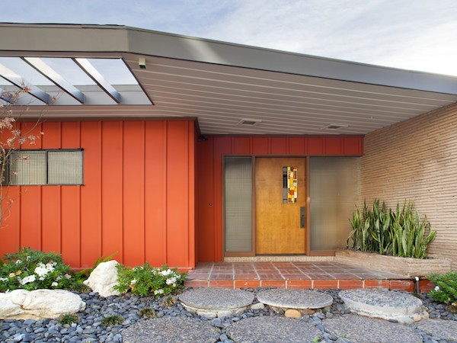

[Images via Sotheby’s Homes](http://www.sothebyshomes.com/Los-Angeles-Real-Estate/openhouses/103239)

**Where:**[**2320 Alto Oak Drive, Los Feliz Oaks**](http://www.sothebyshomes.com/Los-Angeles-Real-Estate/openhouses/103239)  
**When:** Sunday, November 9 from 1:00pm to 4:00pm  
**Asking:** $2.499M  
**What:** The renovation of this 3-bed, 3.5-bath ‘50s ranch unfolded over the course of a year, and it's far from the formulaic Mid-Century Modern renovations cluttering Los Angeles these days. It also involved a very self-confident client– one who was willing to put a sewing nook in a corner of the living room, below. The felted fiber ceiling panels are original to the house:  
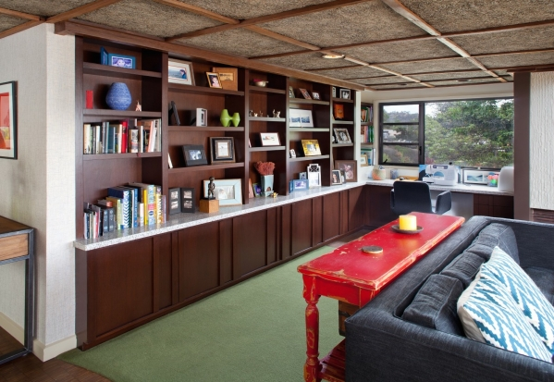  
With multiple seating areas, the rest of the living/dining area opens to a patio– and a view of Los Angeles– as well as the kitchen. We're loving the constellation of Sarfatti pendant fixtures over the Heywood-Wakefield dining table and chairs:  
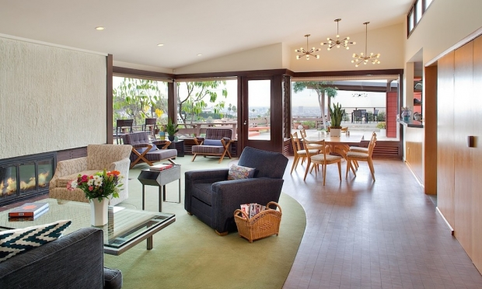  
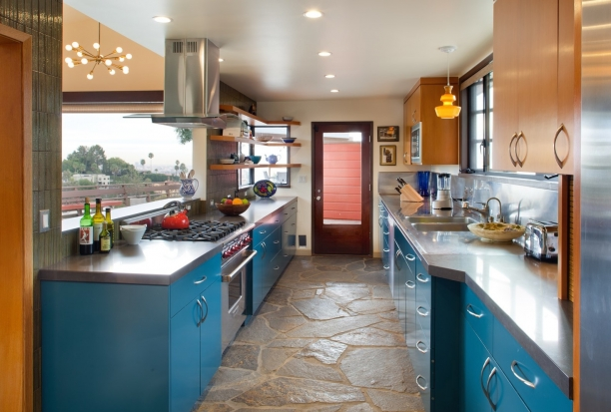  
Below, the master bedroom and what may be the best kid's room, ever:  
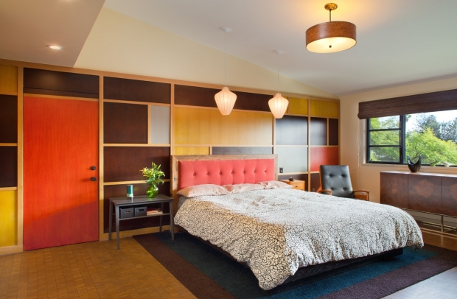  
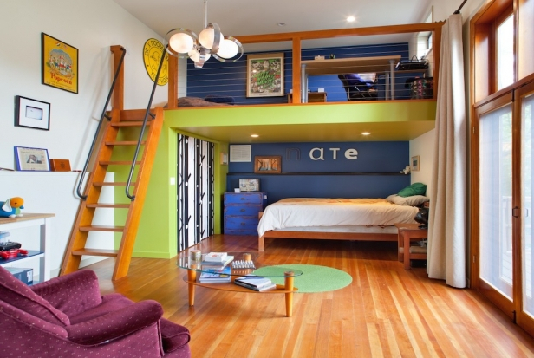  
**Details:** A texture-packed powder room, and the skylit hallway. Most of the house recieved new flooring– here, end cut Douglas Fir blocks that were ser by hand then finished.  
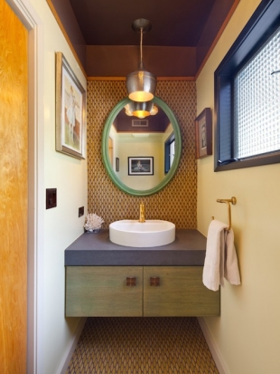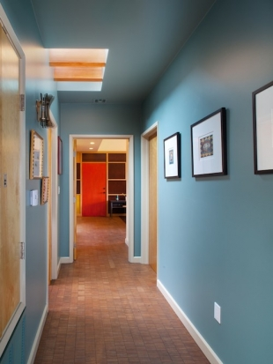  
The deep cinnabar and neutrals palette continues around the house:  
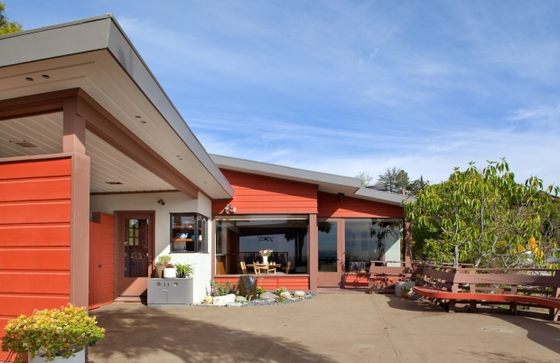  
**More:** For additional images and details, check out the [**listing**](http://www.sothebyshomes.com/Los-Angeles-Real-Estate/openhouses/103239) and the cinematic [**slideshow**](http://www.sothebyshomes.com/Los-Angeles-Real-Estate/openhouses/103239). Have a look at Linda Brettler’s [**portfolio**](http://lindabrettler.com/) for more about her intelligent and eclectic style. Below, an elevated patio looks out to Los Angeles:  
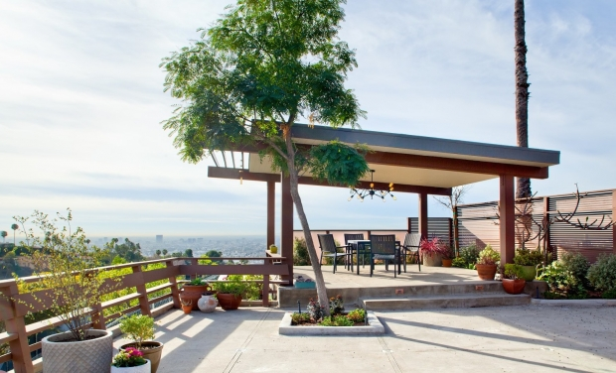

**Blog Type**

[**Property**](http://californiahomedesign.com/taxonomy/term/1718)